**PROJECT PHASE 2**

**Q1.** Display the customer details based on any one of the following: state name or stateAb (For example Texas or TX)

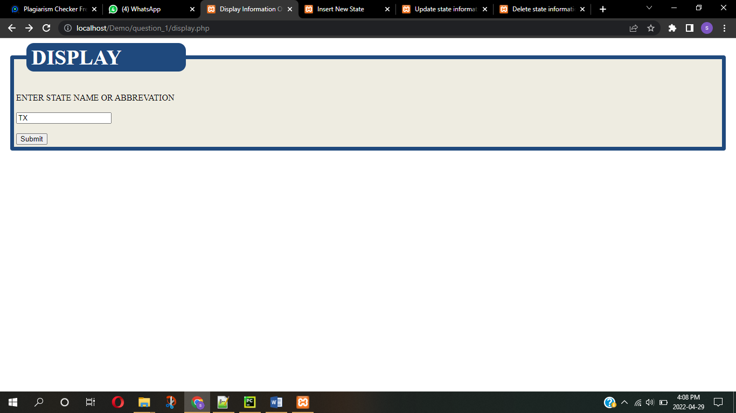

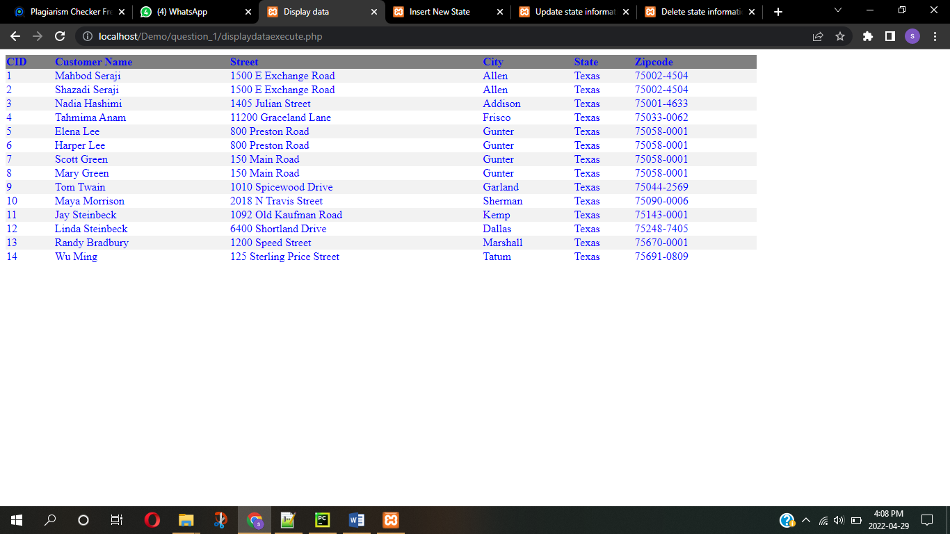

**Q2.** Insert a new state ‘Alaska’, ‘AA’ in the art gallery database using the web interface you created.

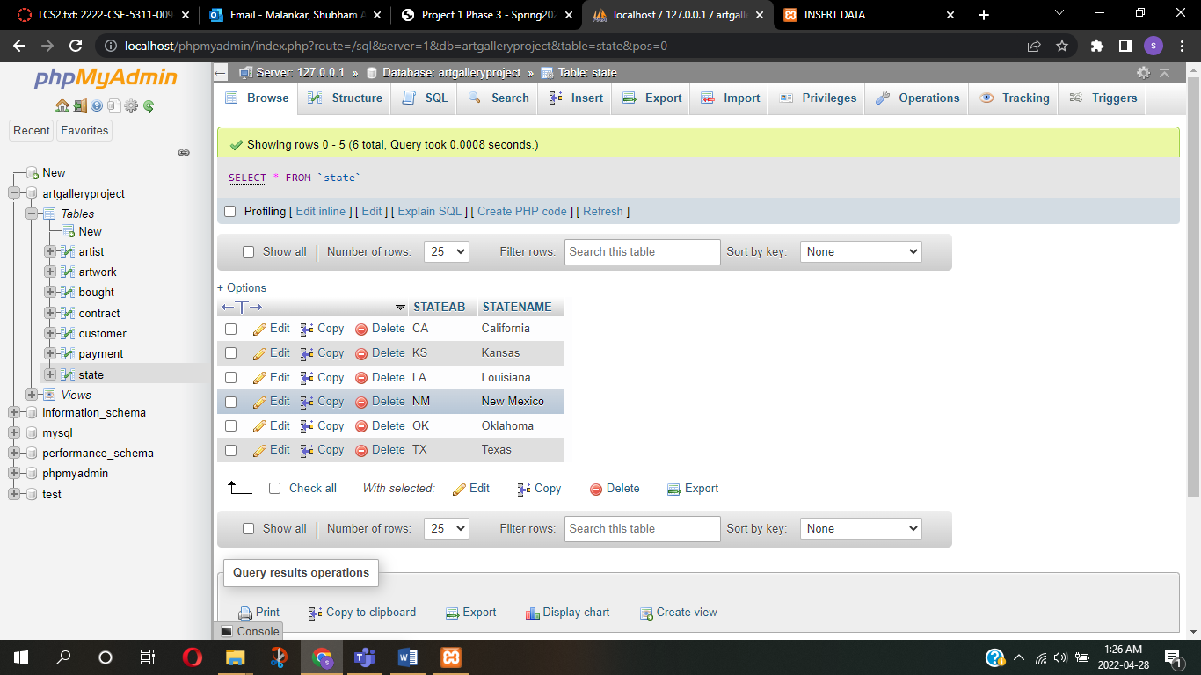

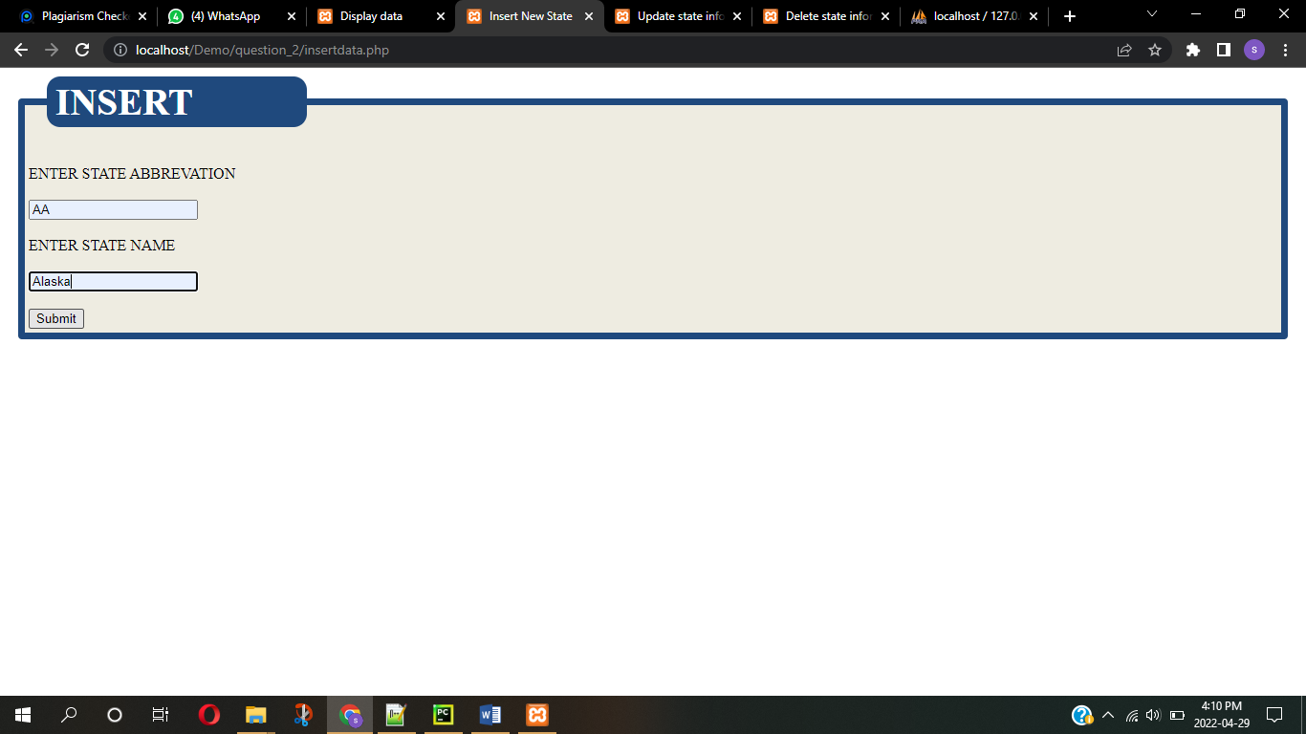

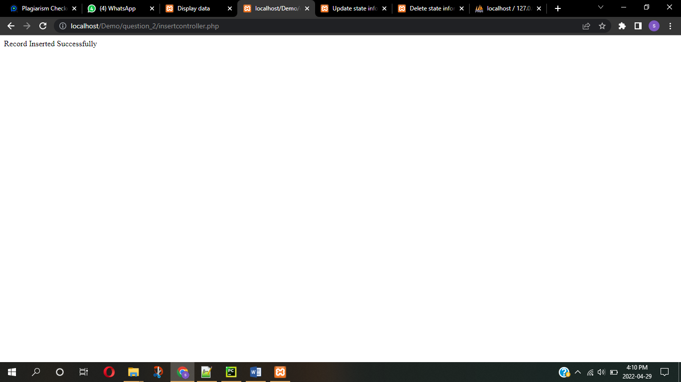

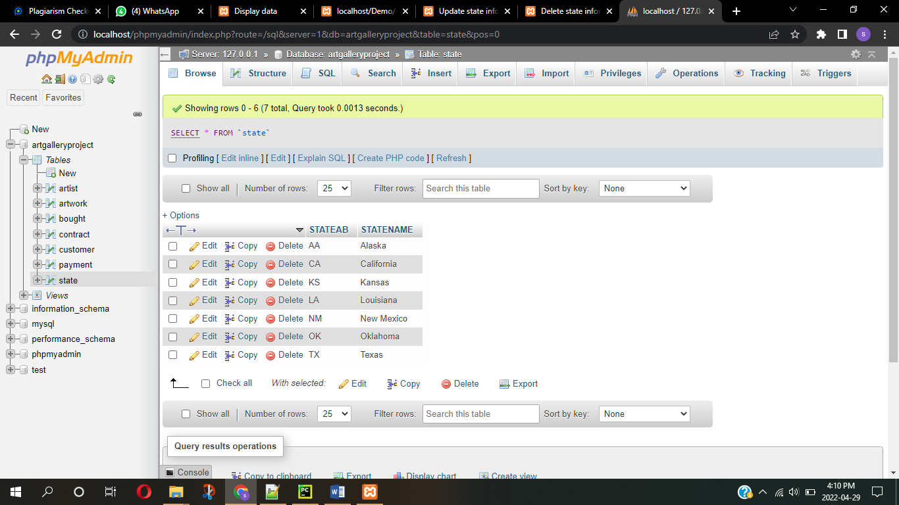

**Q3.** Update the state record that you just added to ‘Alaska’, ‘AK’ using the web interface you created.

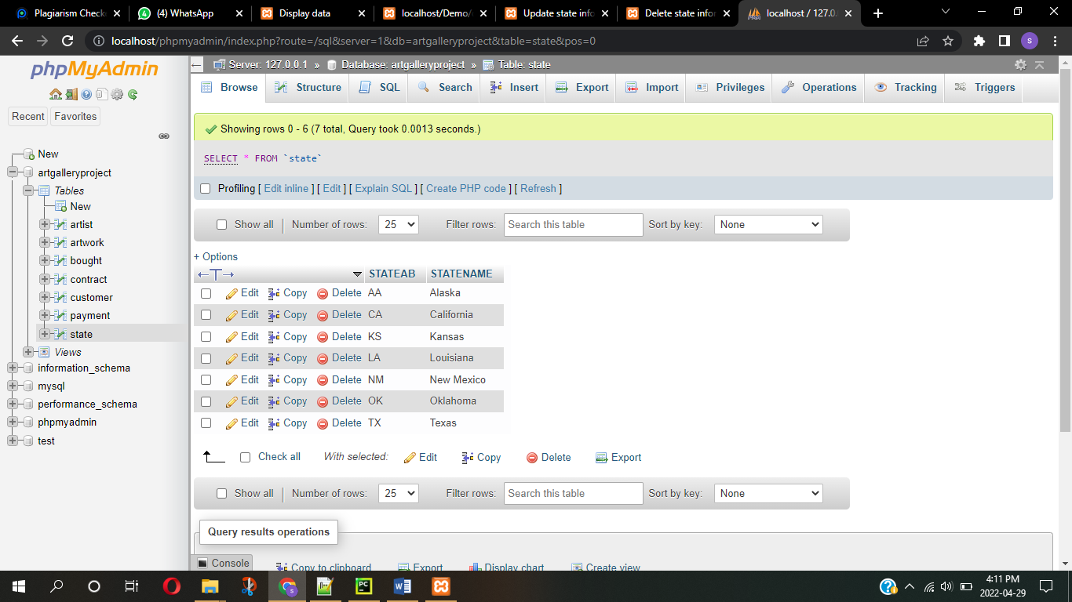

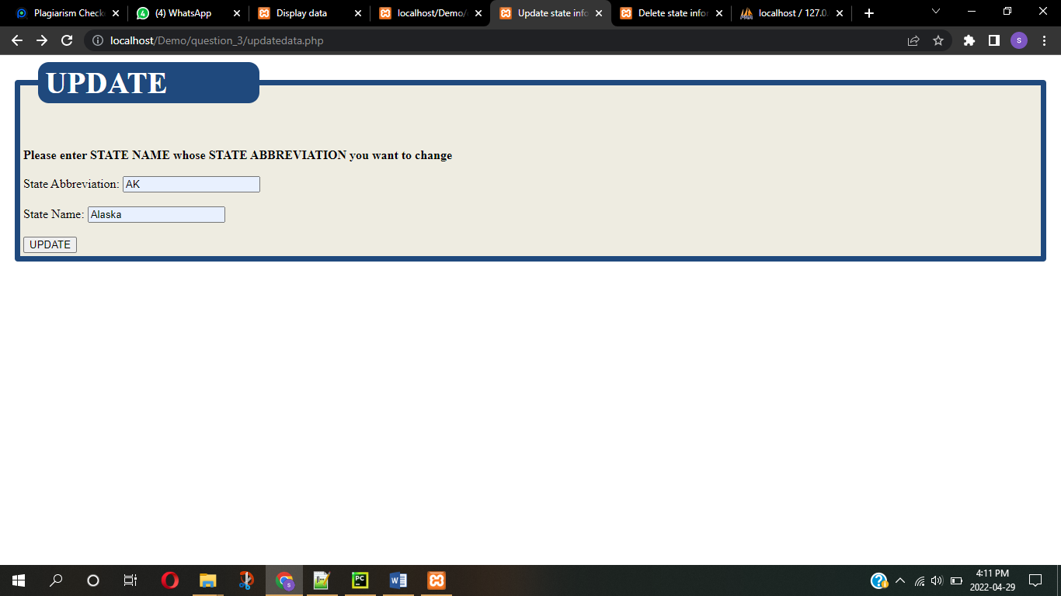

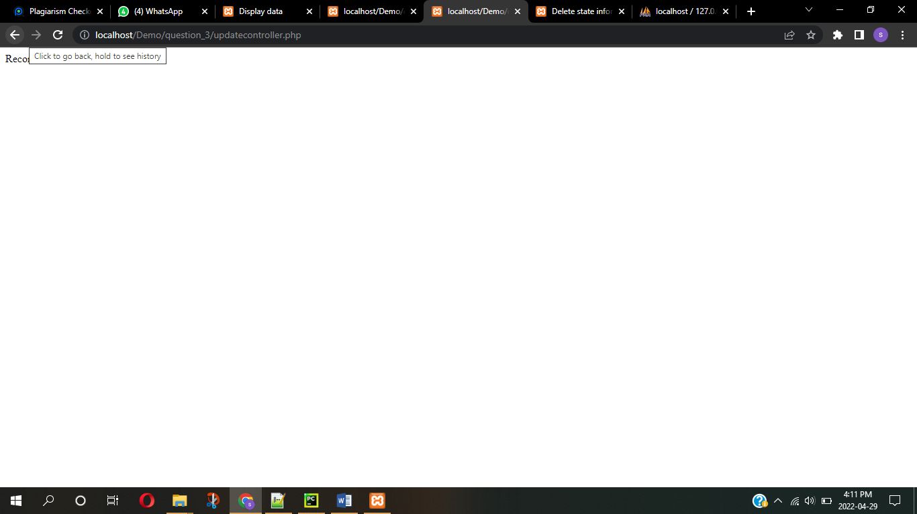

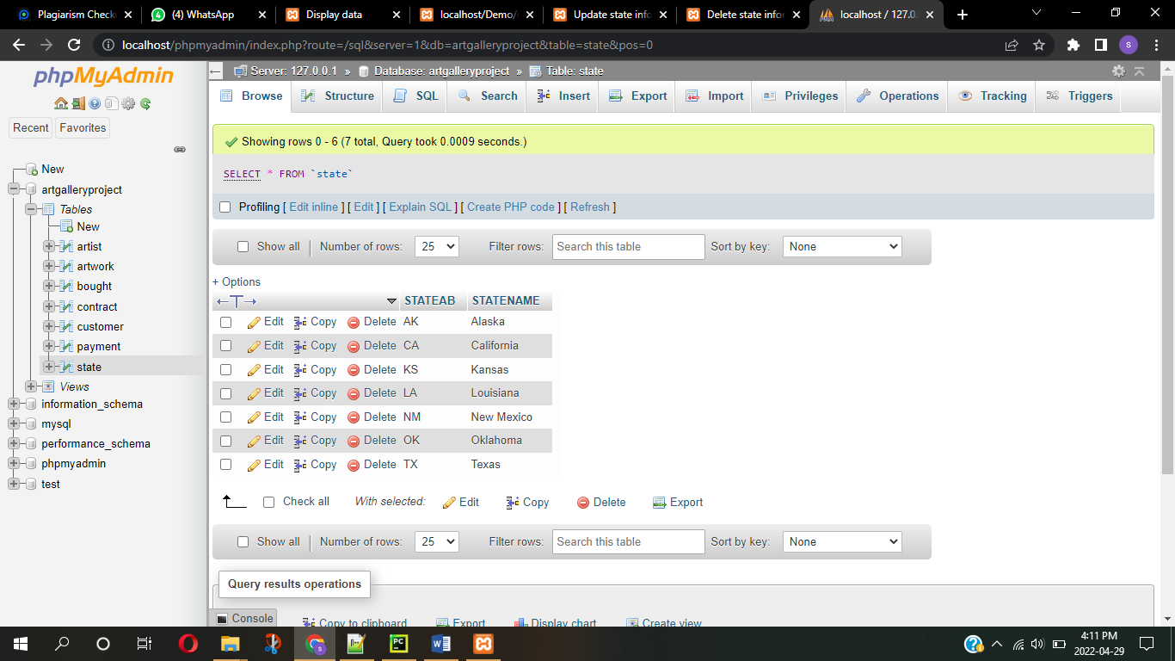

**Q4.** Delete the state of Alaska record that you just added using the web interface you created.

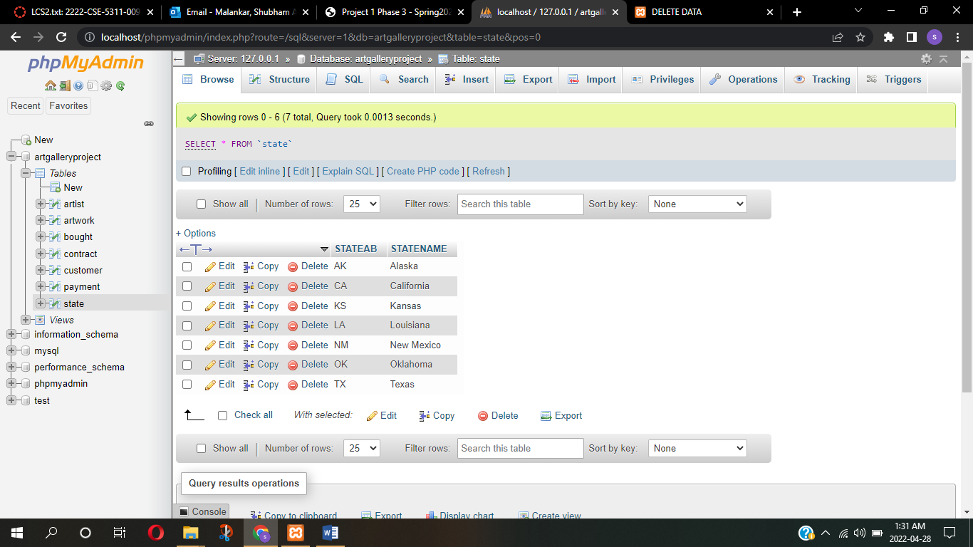

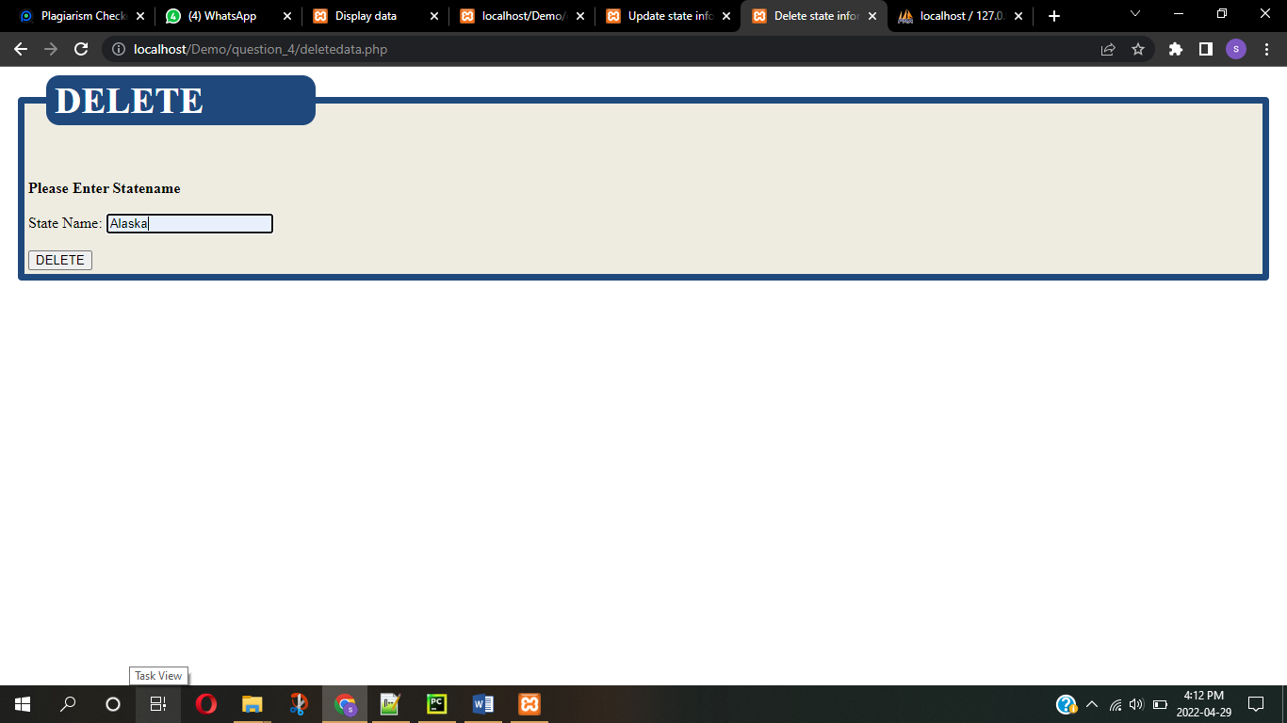

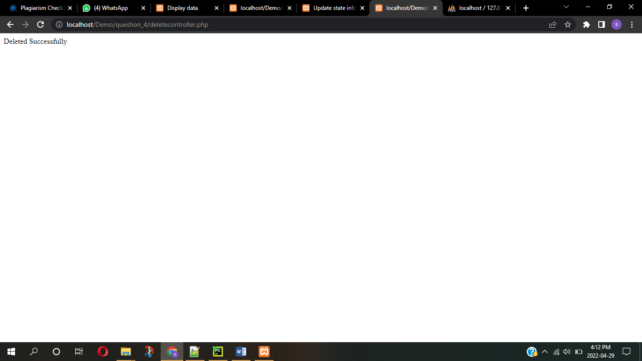

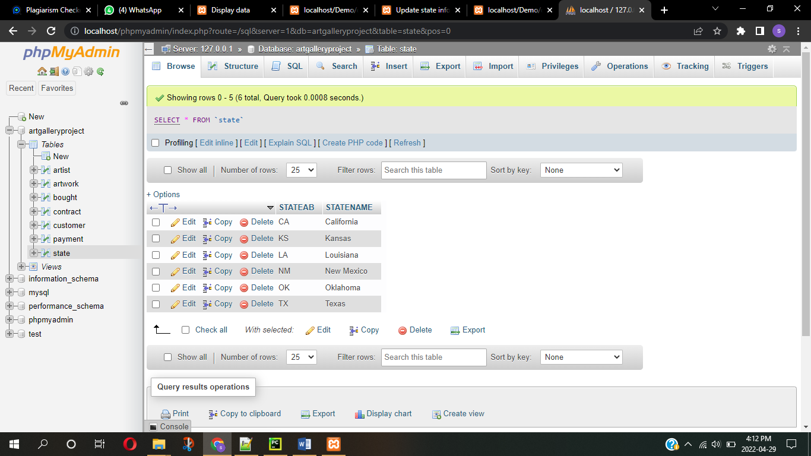

**QV1** Create a view ArtworkView that shows name of artist as ArtistName, his date of birth as Bdate, title of the artwork as ArtworkTitle, the form of artwork as Form, the sale date as SaleDate, the price as ArtworkPrice, the customer’s name who bought the artwork as CustomerName, final date of the payment as FinalPaymentDate, and the acquisition date of that artwork as AcquisitionDate. Records should be sorted by the name of the artist.

**Query -** create view ArtworkView(ArtistName, Bdate, ArtworkTitle, Form, SaleDate, ArtworkPrice,acquisitiondate, CustomerName, FinalPaymentDate) as

select a.name, a.birthdate, w.title, w.FORM, b.saledate, w.PRICE, w.ACQUISITIONDATE, c.name, p.finaldate from artist a join artwork w join bought b join payment p join customer c

where a.aid = w.aid AND w.ARTID = b.ARTID AND w.ARTID = p.ARTID AND c.cid = b.CID order by a.name;

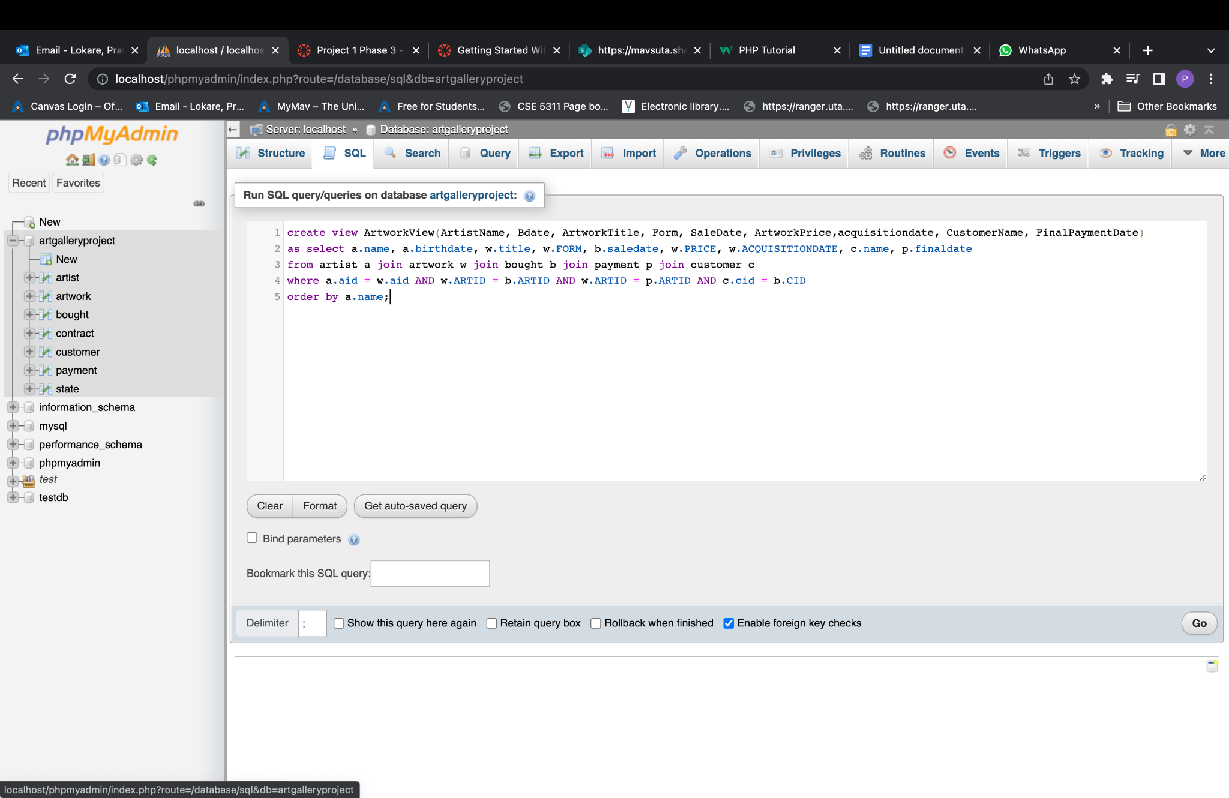

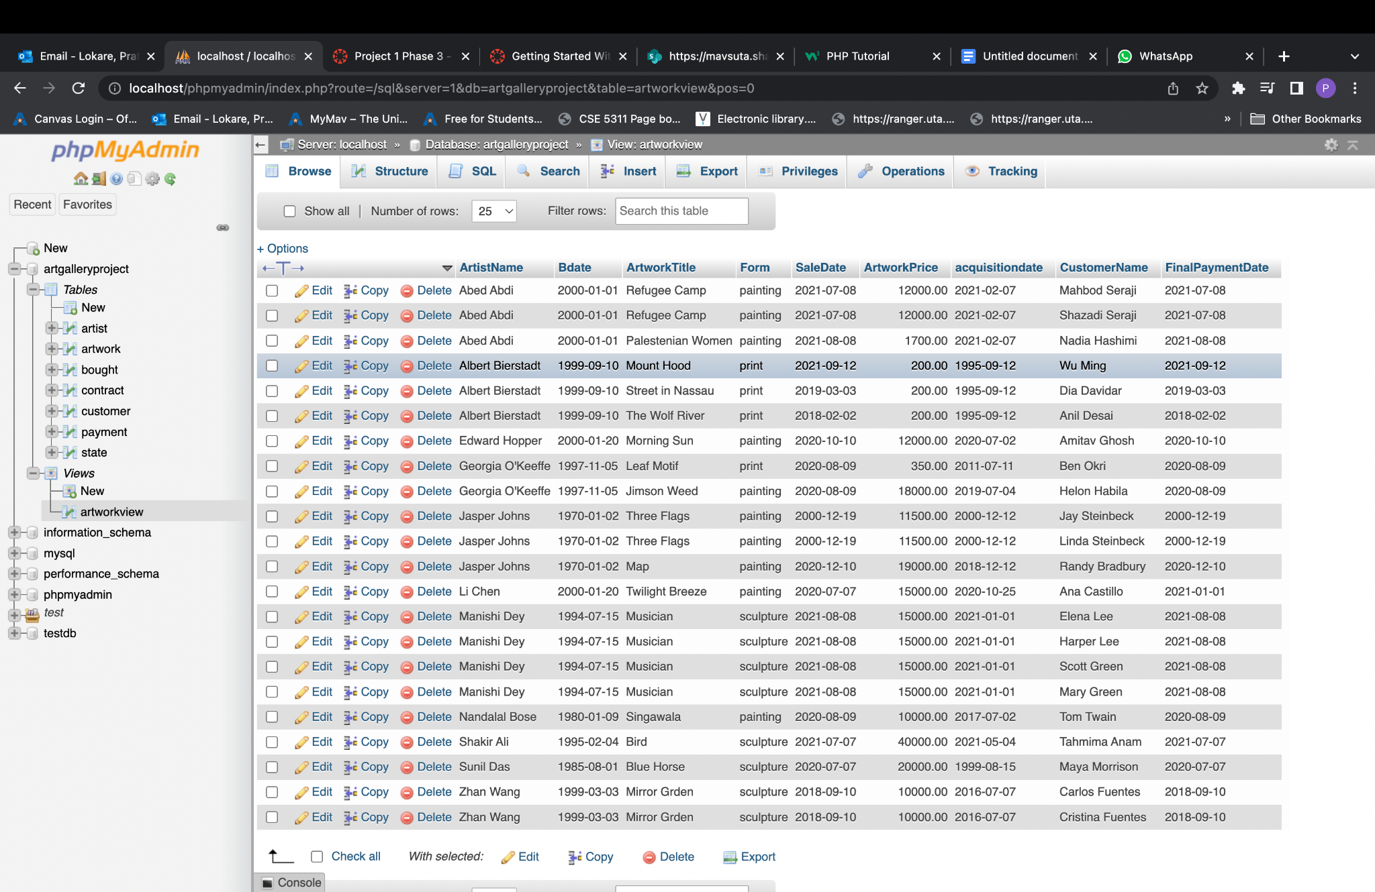

**QV2.** Use the view ArtworkView to retrieve a list of unique names of the artists and their customers when both the names start with vowels.

**Query -** SELECT distinct ArtistName, CustomerName FROM `artworkview` WHERE (`ArtistName` LIKE 'A%' or `ArtistName` LIKE 'E%' or `ArtistName` LIKE 'I%' or `ArtistName` LIKE 'O%' or `ArtistName` LIKE 'U%') and (`CustomerName` LIKE 'A%' or `CustomerName` LIKE 'E%' or `CustomerName` LIKE 'I%' or `CustomerName` LIKE 'O%' or `CustomerName` LIKE 'U%')

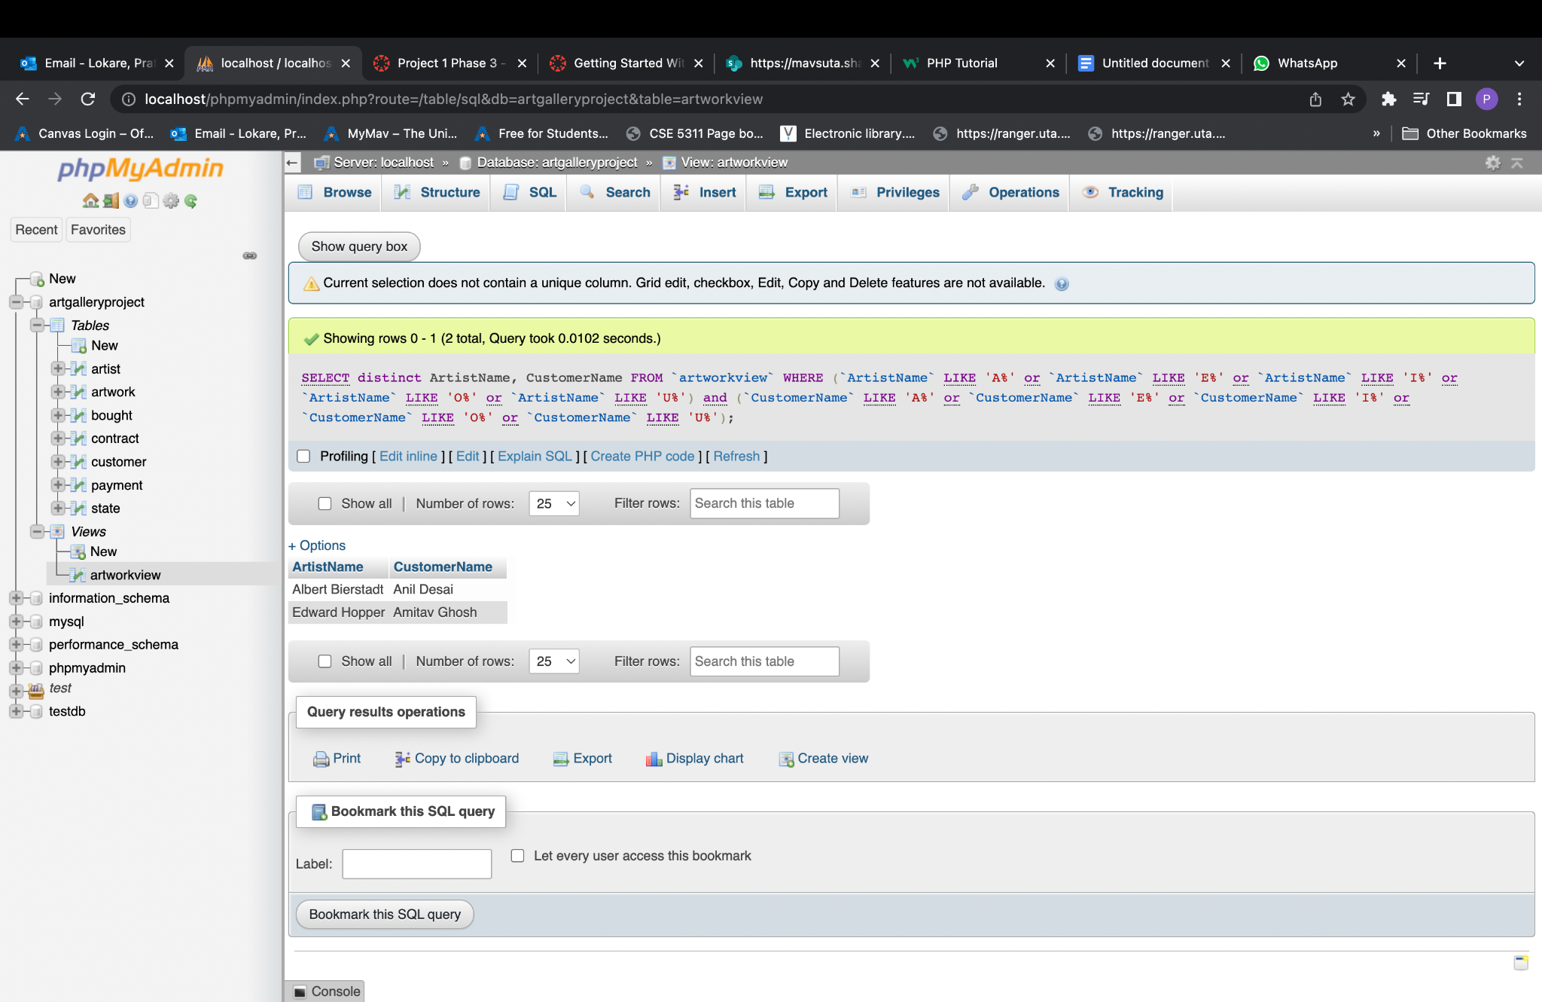

**QV3** Use the view **ArtworkView** to retrieve a list of unique names of the artists whose artwork form is painting.

**Query -** SELECT distinct ArtistName FROM `artworkview` WHERE form = 'painting'

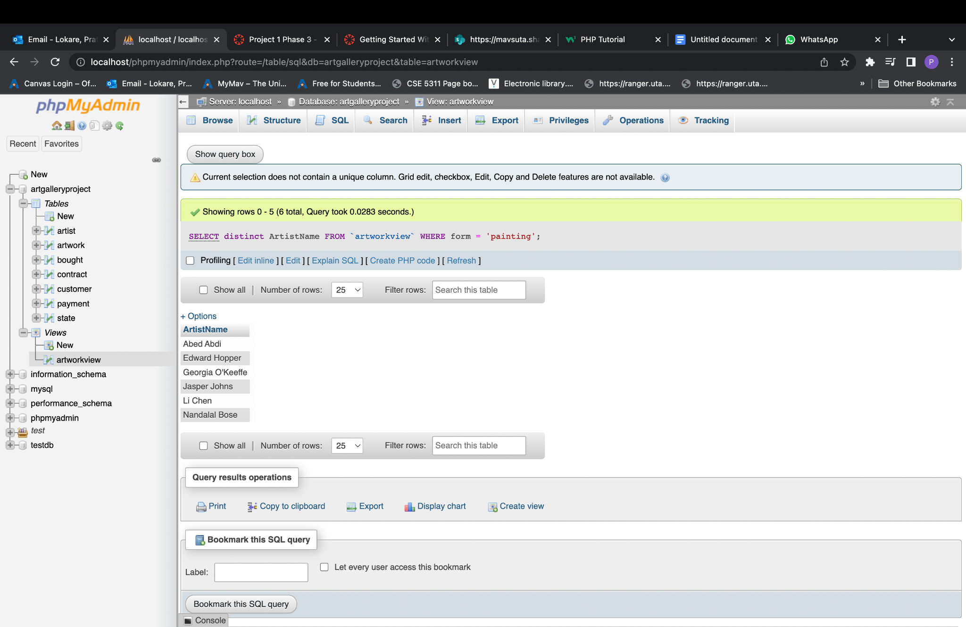

**QV4** Use the view ArtworkView to retrieve a list of unique names of the artists, artwork title, and the price when the price is greater than $250.00 and less than $15,000.00

**Query -** SELECT distinct ArtistName, ArtworkTitle, ArtworkPrice FROM `artworkview` WHERE ArtworkPrice > 250 and ArtworkPrice < 15000

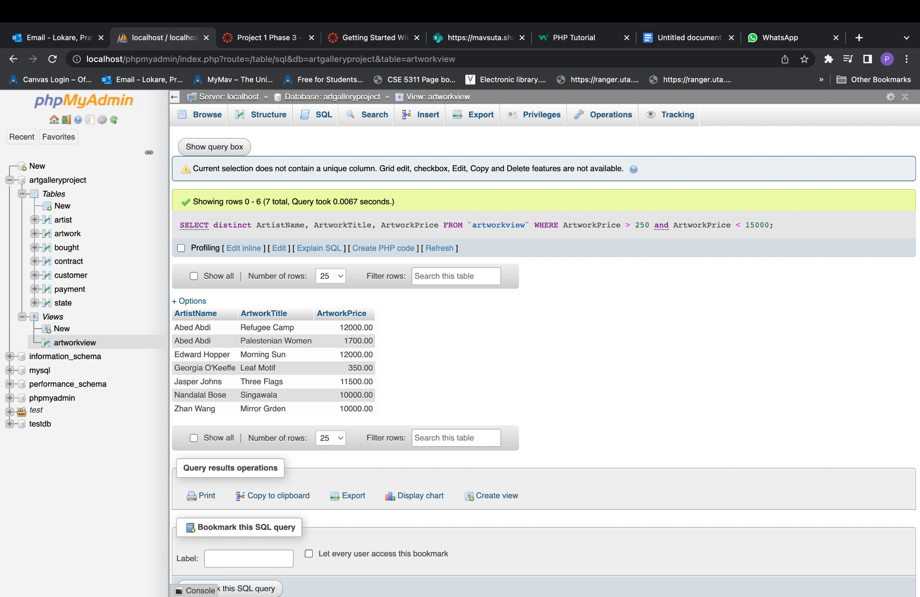

**QV5** Use the view ArtworkView to list the names of the artists and the total number of their art pieces sold so far at the gallery.

**Query -** SELECT ArtistName, count(ArtistName) as ArtworkSold FROM `artworkview` group by ArtistName

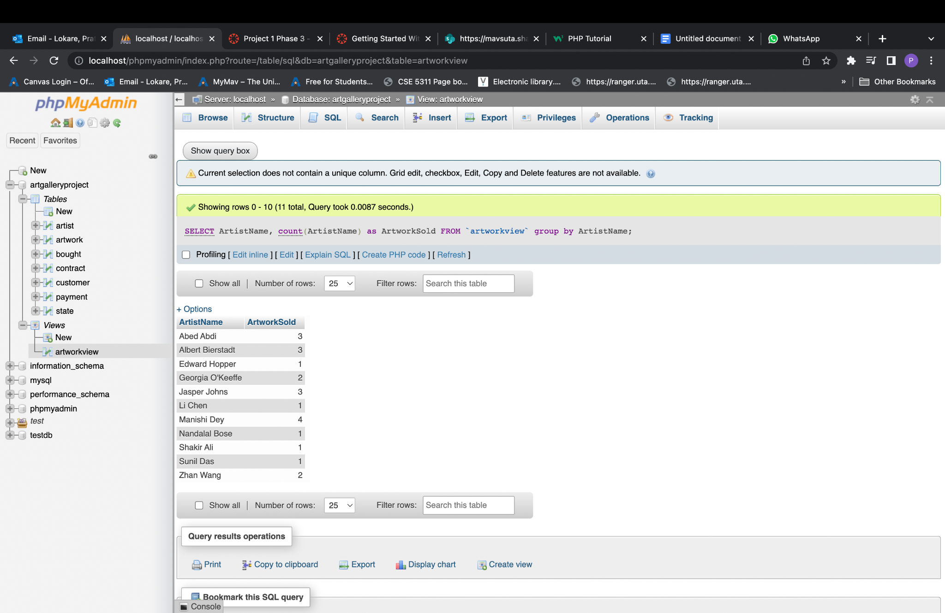

**QV6** For all the artwork that were acquired on 9th September 1995 (1995-09-12), retrieve the name of the artist, his/her date of birth, the title of their artwork, sale date, customer name, and final payment date.

**Query -** SELECT artist.NAME AS ArtistName, artist.BIRTHDATE AS Bdate, artwork.TITLE AS ArtworkTitle, artwork.ACQUISITIONDATE AS acquisitionDate, bought.SALEDATE, customer.name AS CustomerName, payment.FINALDATE AS FinalPaymentDate FROM artist LEFT JOIN artwork ON artist.AID = artwork.AID LEFT JOIN bought ON artwork.ARTID = bought.ARTID LEFT JOIN payment ON artwork.ARTID = payment.ARTID LEFT OUTER JOIN customer ON customer.CID = bought.CID WHERE artwork.ACQUISITIONDATE = '1995-09-12';

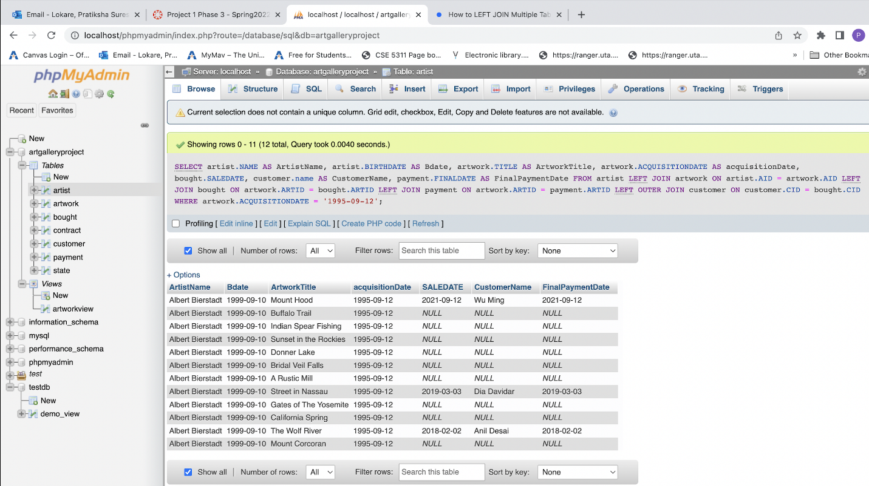

**References –**

1. Fundamentals of Database Systems 7th edition by Elmasri and Navathe
2. <https://stackoverflow.com/questions/19774653/css3-for-html5-legend-inside-fieldset>
3. <https://www.w3schools.com/w3css/defaulT.asp>
4. <https://www.w3schools.com/php/>
5. https://learnsql.com/blog/how-to-left-join-multiple-tables/